Power BI + Ms SQL server

<https://www.youtube.com/watch?v=V-s8c6jMRN0&t=4557s>

[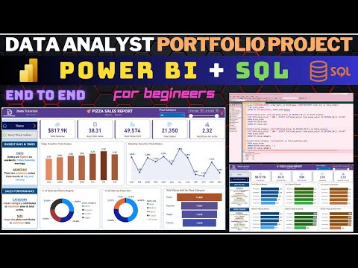](https://www.youtube.com/watch?v=V-s8c6jMRN0&t=4557s)

Ms SQL server Download

<https://learn.microsoft.com/zh-hk/sql/ssms/download-sql-server-management-studio-ssms?view=sql-server-ver16&tabs=command-line>

Power BI Download

<https://www.microsoft.com/zh-tw/download/details.aspx?id=58494>

Ms SQL server

Click Database à New Database à Name: Pizza DB

Click Pizza DB à Tasks à Import Flat file à Specific input file à browse à pizza_sales à modify columns

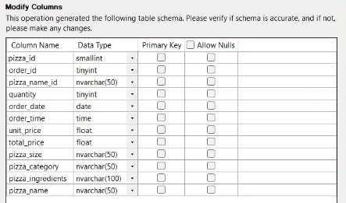before

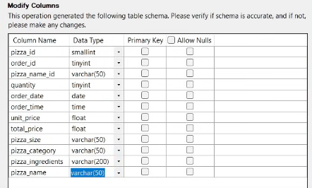after

Nextàfinish

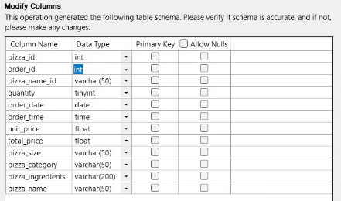

Close

Click PizzaDB à New Query --> Select * from pizza_sales

**PIZZA SALES SQL QUERIES**

**A. KPI’s [30:24-44:29]**

**1. Total Revenue:**

SELECT SUM(total_price) AS Total_Revenue FROM pizza_sales;

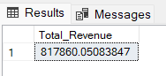

**2. Average Order Value**

SELECT (SUM(total_price) / COUNT(DISTINCT order_id)) AS Avg_order_Value FROM pizza_sales

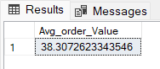

**3. Total Pizzas Sold**

SELECT SUM(quantity) AS Total_pizza_sold FROM pizza_sales

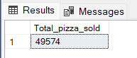

**4. Total Orders**

SELECT COUNT(DISTINCT order_id) AS Total_Orders FROM pizza_sales

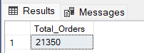

**5. Average Pizzas Per Order**

SELECT CAST(CAST(SUM(quantity) AS DECIMAL(10,2)) /

CAST(COUNT(DISTINCT order_id) AS DECIMAL(10,2)) AS DECIMAL(10,2))

AS Avg_Pizzas_per_order

FROM pizza_sales

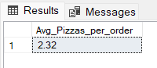

**B. Daily Trend for Total Orders [44:30-]**SELECT DATENAME(DW, order_date) AS order_day, COUNT(DISTINCT order_id) AS total_orders

FROM pizza_sales

GROUP BY DATENAME(DW, order_date)

***Output:***

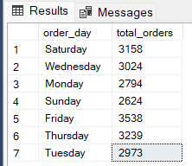

**C. Monthly Trend for Orders**

select DATENAME(MONTH, order_date) as Month_Name, COUNT(DISTINCT order_id) as Total_Orders

from pizza_sales

GROUP BY DATENAME(MONTH, order_date)***Output***

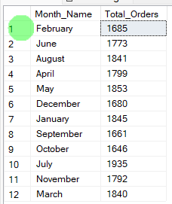

**D. % of Sales by Pizza Category [51:33-]**

SELECT pizza_category, CAST(SUM(total_price) AS DECIMAL(10,2)) as total_revenue,

CAST(SUM(total_price) * 100 / (SELECT SUM(total_price) from pizza_sales) AS DECIMAL(10,2)) AS PCT

FROM pizza_sales

GROUP BY pizza_category

***Output***

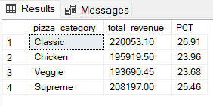

**E. % of Sales by Pizza Size**

SELECT pizza_size, CAST(SUM(total_price) AS DECIMAL(10,2)) as total_revenue,

CAST(SUM(total_price) * 100 / (SELECT SUM(total_price) from pizza_sales) AS DECIMAL(10,2)) AS PCT

FROM pizza_sales

GROUP BY pizza_size

ORDER BY pizza_size

***Output***

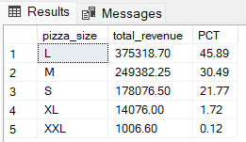

**F. Total Pizzas Sold by Pizza Category**

SELECT pizza_category, SUM(quantity) as Total_Quantity_Sold

FROM pizza_sales

WHERE MONTH(order_date) = 2

GROUP BY pizza_category

ORDER BY Total_Quantity_Sold DESC

***Output***

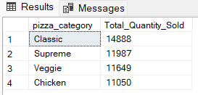

**G. Top 5 Pizzas by Revenue**

SELECT Top 5 pizza_name, SUM(total_price) AS Total_Revenue

FROM pizza_sales

GROUP BY pizza_name

ORDER BY Total_Revenue DESC

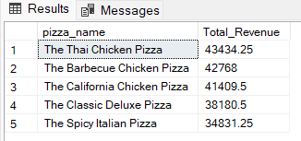

**H. Bottom 5 Pizzas by Revenue**

SELECT Top 5 pizza_name, SUM(total_price) AS Total_Revenue

FROM pizza_sales

GROUP BY pizza_name

ORDER BY Total_Revenue ASC

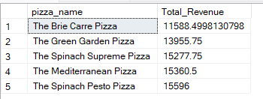

**I. Top 5 Pizzas by Quantity**

SELECT Top 5 pizza_name, SUM(quantity) AS Total_Pizza_Sold

FROM pizza_sales

GROUP BY pizza_name

ORDER BY Total_Pizza_Sold DESC

***Output***

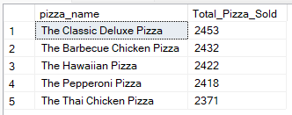

**J. Bottom 5 Pizzas by Quantity**

SELECT TOP 5 pizza_name, SUM(quantity) AS Total_Pizza_Sold

FROM pizza_sales

GROUP BY pizza_name

ORDER BY Total_Pizza_Sold ASC

***Output***

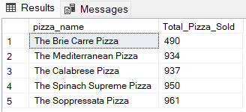

**K. Top 5 Pizzas by Total Orders**

SELECT Top 5 pizza_name, COUNT(DISTINCT order_id) AS Total_Orders

FROM pizza_sales

GROUP BY pizza_name

ORDER BY Total_Orders DESC

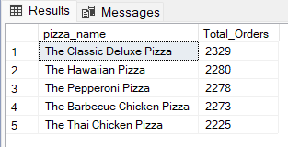

**L. Borrom 5 Pizzas by Total Orders**

SELECT Top 5 pizza_name, COUNT(DISTINCT order_id) AS Total_Orders

FROM pizza_sales

GROUP BY pizza_name

ORDER BY Total_Orders ASC

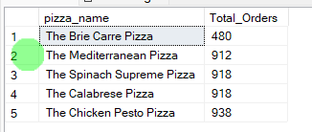

***NOTE***

If you want to apply the pizza_category or pizza_size filters to the above queries you can use WHERE clause. Follow some of below examples

SELECT Top 5 pizza_name, COUNT(DISTINCT order_id) AS Total_Orders

FROM pizza_sales

WHERE pizza_category = 'Classic'

GROUP BY pizza_name

ORDER BY Total_Orders ASC

Power BI Intro [01:10:28](https://www.youtube.com/watch?v=V-s8c6jMRN0&t=4228s)

Get dataàSQL Server database🡪Enter Server🡪Enter Database

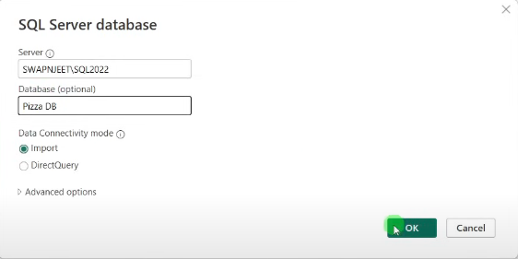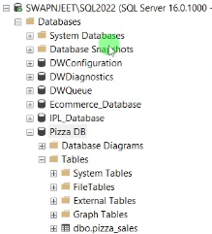

Click pizza_salesàload

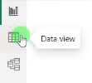

Data Cleaning using Power Query [01:15:57](https://www.youtube.com/watch?v=V-s8c6jMRN0&t=4557s)

* Home🡪Transform data
* In pizza_size column🡪replace value

KPI's Building [01:22:29](https://www.youtube.com/watch?v=V-s8c6jMRN0&t=4949s)

* Card(new) [Total Revenue, Avg Order Value, Total Pizzas Sold, Total Orders, Avg Pizza Per Order]

Data Processing in Power BI [01:46:21](https://www.youtube.com/watch?v=V-s8c6jMRN0&t=6381s)

* In order_date🡪”Date” 🡪 “Day”🡪”Name of Day”🡪New column “Day Name” at the last column
* Create New column🡪Order Day=UPPER(LEFT(pizza_sales[Day Name],3))

Building Daily and Monthly Trend Charts [01:49:09](https://www.youtube.com/watch?v=V-s8c6jMRN0&t=6549s)

* Stacked column chart [Total Orders by Order Day]
* Line chart [Total Orders by Order Month]

Building % of Sales by Category & Size [02:05:44](https://www.youtube.com/watch?v=V-s8c6jMRN0&t=7544s)

* Donut chart [Total Revenue by pizza_category🡪% of Sales by pizza_category]
* Donut chart [Total Revenue by pizza_size🡪% of Sales by pizza_size]
* Funnel chart [Total Pizza Sold by pizza_category]

Adding Insights [02:17:30](https://www.youtube.com/watch?v=V-s8c6jMRN0&t=8250s)

* Stacked column chart [Top 5 pizza by Revenue]
* Stacked column chart [Bottom 5 pizza by Revenue]
* Stacked column chart [Top 5 pizza by quantity]
* Stacked column chart [Bottom 5 pizza by quantity]
* Stacked column chart [Top 5 pizza by Total Orders]
* Stacked column chart [Bottom 5 pizza by Total Orders]

Add Navigator Buttons [02:42:08](https://www.youtube.com/watch?v=V-s8c6jMRN0&t=9728s)

* Insert🡪Buttons🡪Navigator🡪Page Navigator